Table of Contents
Introduction 2
Why purchase a 9010A? 3
Running the 9010A for the first time 4
Compile Simple Hello Program 4
Sending a Program to the 9010A 5
Executing a Program in Memory 6
Working with a Pod 6
Appendix A: RS-232 Cable 7
Appendix B: Pods 8
Appendix C: Programmer’s Reference: Conversions 9
General Conversion 9
Address Lines: 9
Appendix D: Programmer’s Reference: Registers 10

Introduction
This document will hopefully get you started using the Fluke 9010A. It assumes that you have some technical knowledge, have played around with debugging boards, and are considering a Fluke 9010A or have recently acquired a 9010A.

This document was based largely on work done by mowerman, and on a number of documents that were written for the 9010A. There is a large amount of information available, and I have based some segments on this document on Kevin’s work and on the official Fluke documentation. I have tried to write it in such a way that (a) you can skip to the relevant information that you need, and (b) you can get started using your Fluke as quickly as possible.

Recommended reading in addition to this document:

- 9000A-910 Utility Programs PN 661447
- 9010A Service Manual PN 609297
- 9010A Training workbook
- 9010A Operator Manual
- 9010A Course Notes PN 805663
- 9010A Intro Training (TK80 usage)
- 9010A Programming Manual PN 609289
- 9010A Reference Card PN 209271
- 9010A Language Compiler PN 661504
- Fluke Technical Data B0127 (getting started)
- Fluke Technical Data B0163 (probe usage)
- Fluke Troubleshooters (periodic mailer with good tidbits)

To make full use of this document, you’ll need:

- Fluke 9010A base unit with RS-232 option.
- Access to a computer (DOS, or Windows XP. Windows 95, 98, etc., should work, but I haven’t tested them myself).
- A modified RS-232 cable. An explanation of the cable and the modifications are detailed later in Appendix A.
- Software utilities. You’ll need:
  - 9LC.ZIP which contains the compiler and utilities
  - RKSIC.exe, a utility program that makes it easier to work with scripts.
- When you are ready to work on a real board, you’ll need the appropriate Pod.

Why purchase a 9010A?
Some readers may be considering a adding a 9010A to their work bench and may need a little more information on the purpose of the 9010A. Before getting to the “hands-on” section of this document, I’d like to provide a little background information.

Most collectors, board repair shops, or hobbyists will find that their skills evolve over time. Typically one will start out with a DMM, a logic probe, and perhaps even a scope. Certainly by the time that serious repair work is attempted, you will have a work bench set up with many of the common adapters. If you’ve started using these tools and are starting to understand general board architecture, you may be ready to start using a Fluke.

The Fluke series (the 9010A and the 9100) is just another tool in board repair. Simply stated, it will help you isolate board faults to a particular sub-system of the board. Using it at the most basic level, you can compare a known working board to a non-functioning board and usually isolate the problem to a specific area of the board. Additionally, the scripting features of the 9010A allow you to develop custom debugging scripts that exercise specific components, frequently down to the individual chips on the board. This can drastically cut down on repair time.
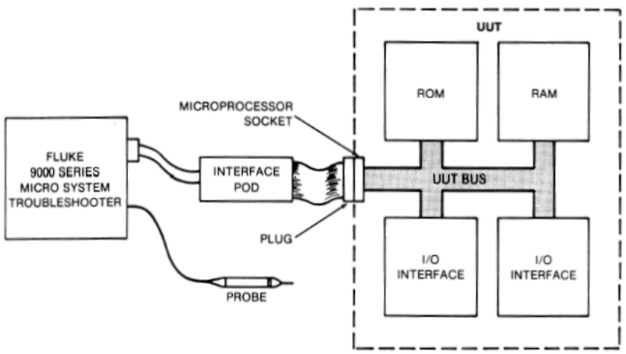
From the Fluke Documentation

Using the Fluke requires that you have a 9000 base unit (i.e. 9010A) and an interface pod (i.e. the Z80 interface pod) that matches your board architecture. You can then use the base unit to exercise the Unit Under Test (UUT). By reading and writing (and testing) specific addresses and control lines, frequently you can isolate the circuitry that is at fault.

The rest of the document will be geared towards the actual use of the 9010A.

Running the 9010A for the first time
Typically, a simple programming task can be used to demonstrate how to get up and running on a new platform. This procedure will help the user make sure that:

- Base unit is operating correctly
- RS232 is operating correctly
- The program can be compiled
- A program can be uploaded to the base unit
- A program can be executed (“Hello World”)

Compile Simple Hello Program
The following is a simple program that can be used:

program HELLOWLD

START:
dpy HELLO WORLD # ! This is a comment
dpy +PRESS YES /1 ! Wait for input

Save this program to a file like “Hello.s”. To compile this program, you will need to find the 9LC.zip file that will contain several utility programs. Run the following:

9LC Hello.s

and you should get something like:

9010A Language Compiler - Version 1.2
Copyright(c) 1983 John Fluke Mfg. Co., Inc.

compiling ...

Program 0 (HELLOWLD) - 37 bytes

TOTAL = 37 bytes

This will create the output program Hello.h. This is the file that you will send to the 9010A. This demonstrates how to use the command line to compile a program. It’s useful to know this in case you use a new compiler like Visual Studio (or similar) and run a make file to build all of your scripts.

You can also use the RKSIC.EXE program. This is a handy tool for editing source files, compiling programs, and transmitting them to the 9010A. [NOTE: I really only use this to send files to the base unit, and eventually I will probably use the XFER.EXE which is probably what RKSIC.EXE uses.]

Sending a Program to the 9010A
Now that you have a sample program compiled, you will need to send it to the 9010A. You’ll need to set up a couple of things:

- The RS-232 cable that you will be using will require modifications to use. See the Appendix for details on building your cable.
- If your 9010A has a GFI option, be sure to turn it off. You will boot into a different mode if you have it turned on.
- Check the back of your 9010A unit. Note the communications settings (they will be labeled). The following settings work very well:
  - Baud: 9600
  - Parity: Even
  - Data Bits: 8
  - Stop Bits: 1
- Run the program RKSIC.EXE and set up the communication settings to match the 9010A. This information is asked the first time you run the program, or you can select menu item 7 (COM settings).

Transferring a program to the unit is pretty straight forward:

- Select menu option 2: Send Hex File to 9010A.
- You’ll get a list of *.h files listed in your current directory. You’ll need to make sure that your compiled files are eventually placed there. (I compile all my scripts in a different location and just have a batch file copy all the *.h files here.)
- Select you file, hit enter.
- RKSIC.EXE will show a message box that says “On the 9010A Press…” The first time that I read through this, I wasn’t sure if I was setting it up correctly. So, just for clarity, these next steps are documented.
- On the 9010A itself, press the AUX I/F button. Essentially it will ask you what you want to do with the port. Hit “READ” to confirm that you want the 9010A to read data. You will be asked to confirm the read (because the current memory will be erased). Press ENTER/YES.
- Back on the computer, press the space bar to start the transfer.

For a small program like this Hello World program, the transfer will be very quick. As you develop larger programs, it will take several seconds to transmit.

Executing a Program in Memory
When the 9010A has completed loading the program, you will receive a message. [TODO: give the specific message.] You are now ready to execute it.

Press the EXEC button. You’ll be asked for which program to execute. There can be up to 100 (maybe 99?) programs. When you load a program from your PC, the first program in your source is placed at the first location. Makes sense, right? You can execute this first program by just hitting ENTER/YES button.

Doing so with the Hello World program will cause your screen to display:

[TODO: insert picture]

Note that all of this was done without connecting a pod. New 9010A users will probably want to do something this simple to get familiar with the platform and confirm to themselves that the base unit and computer are communicating properly.

Working with a Pod
The above just demonstrates the ability to program the 9010A offline and then run the program. Creating a debug script is not necessary, but enhances your debugging capabilities significantly. You can also issue commands using the 9010A keypad.

Regardless of your approach to debugging, you will need to purchase a Pod that matches your target platform. See the Appendix for a list of common pods. Typical Pods to have on hand for classic games include the 6502, Z80, and 6800.

The Pod plugs into the front of the 9010A and should be cleared marked. Attach the Pod (with the power off) and then power up your 9010A. You should make a habit of running the self test on the Pod. This is done by plugging the Pod’s plug into the Pod’s ZIF socket. On the 9010A, press RUN UUT and then ENTER.

Appendix A: RS-232 Cable
In order to connect your computer to the Base Unit, you will need to modify a RS-232 cable.

Base Unit End (DB9) | Computer End (DB25)
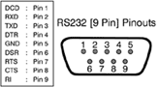 | 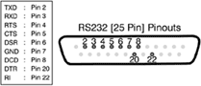

Note that the cables should be female on each end. On the DB9 end, make the following jumps:

DB9
Jump Pin 4 to Pin 6 (DTR to DSR)
Jump Pin 7 to Pin 8 (RTS to CTS)

You may want to buy (or find) cables that have both DB9 and DB25 hooked up at both ends. [TODO: Insert Picture.] These cables were sold with software products such as LapLink that were made so that you could transfer files between computers. Using a cable like this makes it easy to insert jumpers because you can just use a little bit of wire on the unused end.

IMPORTANT NOTE: A simple null modem cable purchased online at one of the discount computer suppliers should work. A female DB9 to female DB25 should work.

Appendix B: Pods

Pod/Part Number | Comments
Fluke/9000A-6502 | Gottlieb/sys80 sound boards.
Fluke/9000A-6800 | Various pinball games.
Fluke/9000A-68000 | Quantum, some later games.
Fluke/9000A-6802 | Williams sound boards and pinballs.
Fluke/9000A-6809 | Williams CPU boards. Very useful.
Fluke/9000A-80186 | Not used for coin-op repair.
Fluke/9000A-80188 | Not used for coin-op repair.
Fluke/9000A-80286 | Not used for coin-op repair.
Fluke/9000A-8048 | Some coin-op use: slots, perhaps Donkey Kong (with mods).
Fluke/9000A-8051 | Valuable to embedded developers. Not sure about coin-op use.
Fluke/9000A-8080 | B&W Midway games.
Fluke/9000A-8085 | Phoenix and a few others.
Fluke/9000A-8086 | Not used for coin-op repair.
Fluke/9000A-8088 | Some Gottlieb games (Q*Bert).
Fluke/9000A-9900 | Not used much or at all.
Fluke/9000A-Z80 | Many video games (Galaga, Dragon’s Lair, many, many more)

Appendix C: Programmer’s Reference: Conversions

General Conversion

Dec | Oct | Hex | Binary
00 | 00 | 0 | 0000
01 | 01 | 1 | 0001
02 | 02 | 2 | 0010
03 | 03 | 3 | 0011
04 | 04 | 4 | 0100
05 | 05 | 5 | 0101
06 | 06 | 6 | 0110
07 | 07 | 7 | 0111
08 | 10 | 8 | 1000
09 | 11 | 9 | 1001
10 | 12 | A | 1010
11 | 13 | B | 1011
12 | 14 | C | 1100
13 | 15 | D | 1101
14 | 16 | E | 1110
15 | 17 | F | 1111

Address Lines:

Bit | Binary | Hex
A0 | 1 | $1
A1 | 10 | $2
A2 | 100 | $4
A3 | 1000 | $8
A4 | 10000 | $10
A5 | 100000 | $20
A6 | 1000000 | $40
A7 | 1000 0000 | $80
A8 | 100000000 | $100
A9 | 1000000000 | $200
A10 | 10000000000 | $400
A11 | 100000000000 | $800
A12 | 1000000000000 | $1000
A13 | 10000000000000 | $2000
A14 | 100000000000000 | $4000
A15 | 1000000000000000 | $8000

Appendix D: Programmer’s Reference: Registers

Register | Logical Name | Description
REGA | BITMASK | Bit mask. The last bit mask specified by the programmer.
REGB | ROMSIG | ROM signature. The last ROM signature specified by the program.
REGC | STSCTL | STS/CTL information. The last status/control information specified by the program.
REGD | BITNUM | Bit Number. The last bit number specified by the programmer in an toggle address, toggle data, or toggle data control function.
REGE | DAT | Data. The last data specified or generated.
REGF | ADR | Address. The last address specified or generated.
REG0 | PBDAT | Read probe data. Data accumulated by the Read Probe operation.
REG1-REG7 |  | “Local” registers.
REG8-REG9 |  | “Global” registers.

- Registers REGA-REF0 are considered “dedicated” registers and may be updated by specific program statements. However, these registers can be manipulated by the programmer. They are also global.
- Registers REG1-REG7 are considered “non-dedicated” registers and the programmers can use them at will. They are local the program being executed, and will be erased when an “executed” command is used.
- Registers REG8-REG9 are also considered “non-dedicated” however, they can be used to pass parameters from one program to another. For example, you can write a generic “delay” routine and use REG8 to pass in the number of “ticks” to delay.

Declarations syntax
Registers can be given “readable” variable names to make code easier to follow. This is the syntax:

program FOO !! the “foo” program

declarations !! declarations sect

!! assign <reg> to <variable>
assign REG1 to Input !! can use “Input” now

dpy SHALL WE PLAY A GAME?_/1
if INPUT = 1 goto GAME !! readable name, REG1

That’s not to say that you shouldn’t start using a Fluke if you don’t have a scope or logic analyzer. However, using these tools to do some basic debugging will go a long way in helping you understand the methodology of debugging a hardware problem.

